**PENOROS TEAM**



NASA Space App Challenge 2018

**THE CHALLENGE:**Design an autonomous free-flyer to inspect a spacecraft for damage from Micro-Meteoroid and Orbital Debris (MMOD).

For more details:

<https://2018.spaceappschallenge.org/challenges/can-you-build/design-based-nature-fusion/details>

**Quick answers**

***What components, structures, or patterns of Nature (or inspired by Nature) are your machine and/or operations sequence based on?***  
To develop this free-flyers system we based on some natural strategies, such as the tridimensional structure of methane, bees’ division of tasks, heart valves and snakes’ infrared thermal sensing.

***What types of sensors will your flyer use? Visual? Electromagnetic? Sensors based on sound?***Our flyers will use mainly the following types of sensors: cameras working in the range of visible light frequency, a laser diastimeter, a laser thermopile sensor and a laser 3D scanner.

In your designs, you may consider the following (this is not an exhaustive list):

* Dimensions of the damage: The width of the MMOD entry hole is usually small compared to the depth; angle of impact is not known
* Lighting and shadows: light sources/shadows, surface reflections, view angles, camera/sensors
* Inspection surface: Cone-shaped inspection surface geometry; distance of free-flyer from inspection surface
* Zero-g, vacuum of space, orbital mechanics/relative motion (would capsule be made to spin to support survey, or not spin to support damage site characterization?)
* Flight plan optimization for reliable results, free-flyer efficiency, and/or spacecraft efficiency (e.g., propellant/power used, inspection time, etc.)
* Autonomy and minimum crew time (In-space or on-ground? Would you use local or remote communications? On-board imaging and processing? What type of decision logic would you use to direct the free-flyer operations?)

Every CubeSat has a camera which covers a limited and defined surface of the spacecraft and which is able to take high resolution photographs using also flash in case of low light conditions.   
Meanwhile the laser on each CubeSat gives back a model like a 3D scanner.  
The flyers stand at 20 meters from the surface of the spacecraft. When a collision is detected, the Cubesat reduces the distance to 10-12 meters to make the measurements.  
Each flyer is equipped with autonomous reaction wheels and propulsion systems, in particolar two ion-based engines are mounted on every CubeSat.   
The reliability of the results is given by the possibility of using more CubeSats, monitoring all the surface on the spacecraft.  
The satellites can be refilled with fuel when docked to the mothership.   
When a possible damage is detected, the flyer approches the impact zone using the ions-based propulsion engine, it takes a photograph and a 3D scan. Then, moving around, other four photographs and 3D scans are taken from different angles using the combination of reaction wheels and propulsion system.  
The energy, provided by the Sun, is potentially illimited. When the fuel tank is fully supplied, the engine is able to produce a thrust of about 1mN.   
The captures and scans obtained are transfered to the mothership which hosts a powerful computer, able to elaborate the datas.

**Presentation:**

How can we monitor the surface of a spacecraft to be sure it will be able to carry its mission out?

The basic idea is to develop a system of mini satellites (called Bees., similar to CubeSats) which can monitor the state of a vehicle they are associated with. This method allows the scientists to evaluate the health condition of the spaceship during its mission, making them able to identify scratches, holes, abrasions and damages.   
We focused our project on a system of 4 flyers, ideal to monitor a small dimension spacecraft.

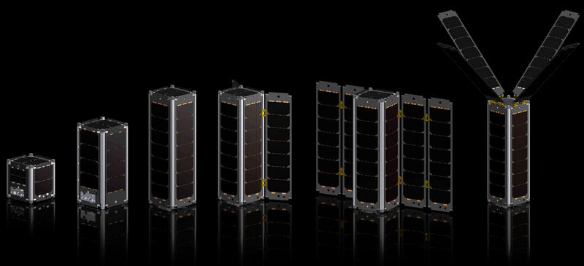

Figura 1 - http://www.spaceflightinsider.com/wp-content/uploads/2016/04/CubeSats-Vector-Space-Systems-photo-posted-on-SpaceFlight-Insider.jpg

Satellites are powered by solar energy and the propulsion is based on ion engines. When the fuel (a heavy gas like argon or kripto) is running out the satellites are refilled thanks to pressure gradient force.

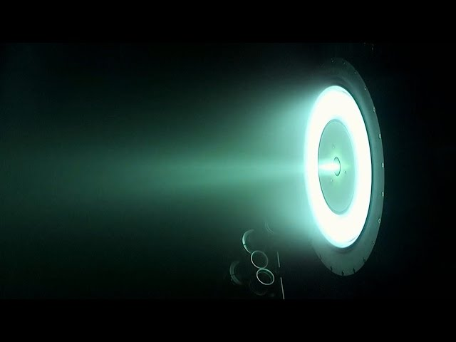

They are equipped with a camera and three lasers. The camera, which will capture different kind of visions, is supposed to offer images of the structure, damages and the position of the cubesats. Each laser has a different function, one kind is used to control the surface of the structure to recognize possible impacts that created a variation of temperature. The other two are supposed to control the position of the cubesat and to take a 3D scan of the damaged area.

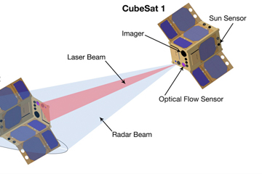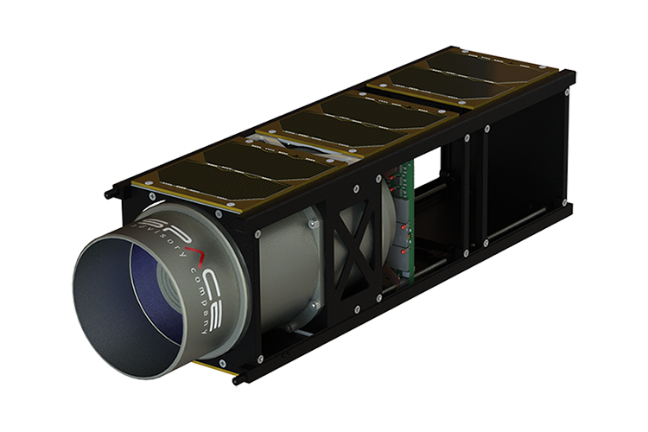

Figura 2 - https://www.cubesatshop.com/wp-content/uploads/2018/03/Chameleon_cubesat_imager_3U.png

During a long space travel these satellites are undocked from the mother spaceship and they occupy a region the shape of a tetrahedron.

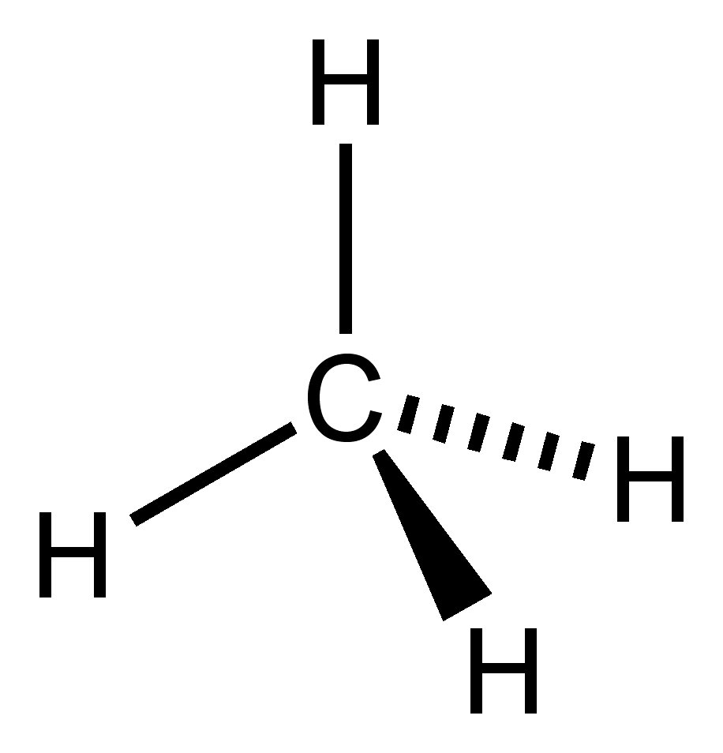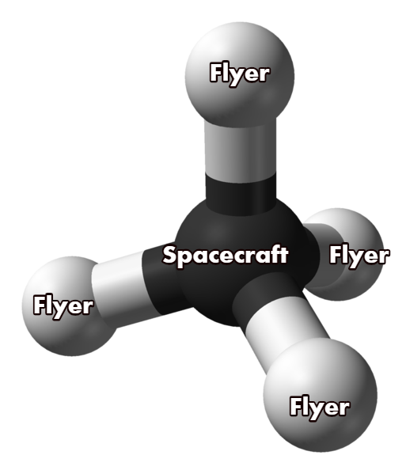

Figura 2 - http://justnewfew.blogspot.com/2011/05/organic-chemistry-3d-models3d-images3d.html

The docking process is inspired by heart valves: like in blood circulation we used difference of pressure to obtain a hermetic closure and a double valve to increase the efficienty of the system.

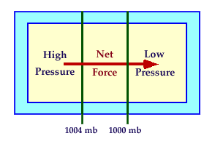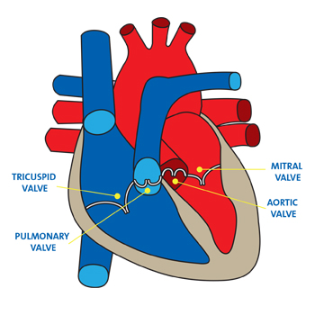

Figura 3 - https://www.premierhealth.com/uploadedImages/PremierHealth/My_Health/Services/Cardiology/Structural_Heart_Program/Heart-Valves-350x350.jpg

To mantain a precise position they measure the distance from themselves and one of them measures the distance from the ship. In particular, the first flyer, after the undocking maneuver, stops its motion at a defined distance from the spacecraft. Once the first satellite has positioned, the second is released and calculates its location depending on the first flyer’s position. The third one’s measures are based on the second’s spot and the fourth cubesat depends on the third.

Once the positioning maneuver is complete each flyer turns off all the sensors, activating the thermal camera.. This operation is intended to preserve energy.

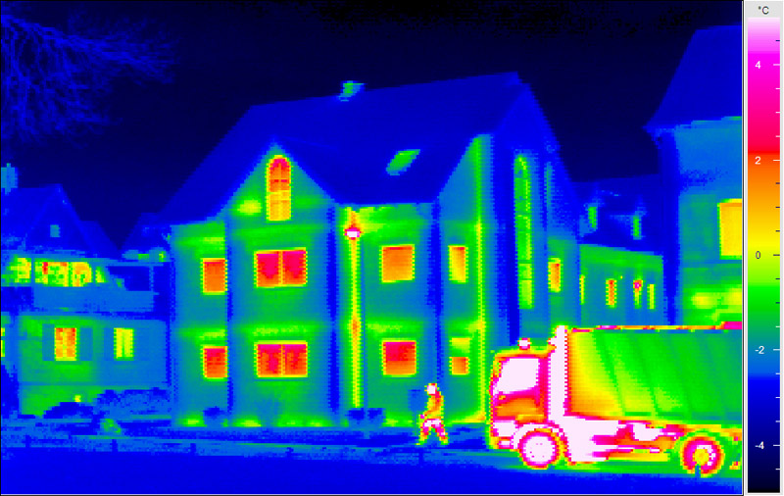

Figura 4 - https://rangefindernow.com/wp-content/uploads/2018/03/thermal.jpg

The assestment of a damage is preceded by two possible strategies:

1) An internal sensor detects an anomaly (fox example a depressurization). As soon as it is possible, the flyers are undocked from the spacecraft to investigate the extent of the damage.

2) The CubeSats are undocked for a patrol and, during the reconnaissance, a thermal mark is captured. The reveal is sent to the control center, which can decide to make the flyer effectuate a more accurate examination.

When the thermic camera identifies a collision between an object and the spaceship the nearest CubeSat fires on the engine and starts to approach the zone of collision. When it is quite near it rotates and decreases its velocity. When it calculates to be motionless it re-rotates and scans the possible damage, sending the result to the mothership which will then transfer the informations to the control center.

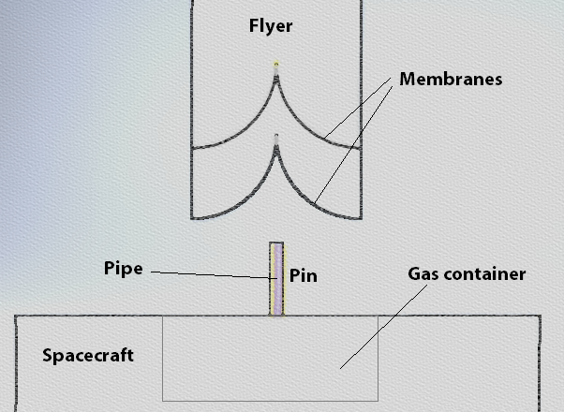The docking system, inspired by heart valves, wors on the **principle** of **pressure**, **pressure gradient**. The flyer has four pins which, during the docking, are inserted in two membranes. By that way if one of the two bumps into a malfunction, the other can still work properly. In two of the pins there are ducts in which gas can flow, refueling the flyer, in the other two pins there are data links. Moreover, when docked, the batteries of the small satellites are recharged.  
During the approaching motion, the CubeSat compresses a mechanic spring which is immediately blocked. When the undocking moment arrives, the spring is released to make the flyer depart from the mother ship.

Figura 5 - Docking system

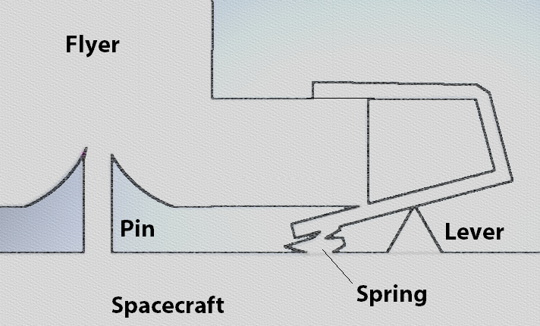

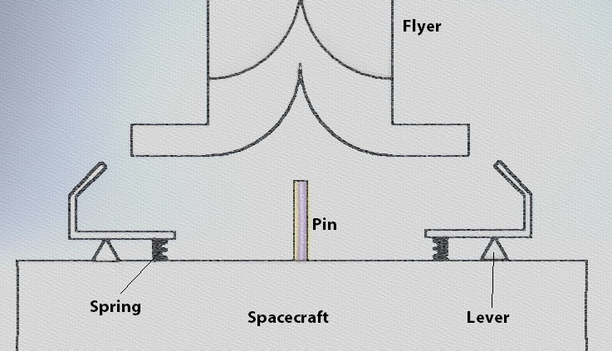

**Scientific proofs to prove the feasibility of the project**

Our flyers are based on CubeSats: small satellites, light and cheap but capable of perform different useful tasks. In particular, the dimensions of the flyers are 20cm x 10cm x 10cm (which is the size of a 2U CubeSat).  
<https://it.wikipedia.org/wiki/CubeSat>

The propulsion system mounted on the flyers is a ion engine capable of transmitting delicate thrusts to the small satellite.  
<http://www.busek.com/technologies__ion.htm>

To maintain its asset each flyer is equipped with reaction wheels, making them capable of rotate into space.  
<https://n-avionics.com/subsystems/cubesat-reaction-wheels-control-system-satbus-4rw/>

<https://cubespace.co.za/cubewheel/>

<https://www.researchgate.net/publication/251889729_Reaction_wheel_design_for_CubeSats>

The flyers are able to take photographs thanks to a high resolution camera.

<http://www.xcam.co.uk/c3d-cubesat-camera>

<https://www.researchgate.net/publication/259532420_A_survey_of_camera_modules_for_CubeSats_-_Design_of_imaging_payload_of_ICUBE-1>

<http://scs-space.com/payloads/chameleon/>

The flyers are able to perform 3D scans thanks to a laser system.  
<https://www.researchgate.net/publication/324982062_DISCUS_-_The_Deep_Interior_Scanning_CubeSat_mission_to_a_rubble_pile_near-Earth_asteroid>

<https://www.researchgate.net/publication/321192556_Imaging_lidar_technology_development_of_a_3D-lidar_elegant_breadboard_for_rendezvous_and_docking_test_results_and_prospect_to_future_sensor_application>

To detect collisions and impact zones, each flyer is equipped with a thermal infrared imager.

<https://technology.nasa.gov/patent/GSC-TOPS-138>

<https://www.techbriefs.com/component/content/article/tb/techbriefs/imaging/22391>

<https://www.vision-systems.com/articles/2016/08/lockheed-martin-developing-infrared-camera-that-will-launch-to-the-moon.html>

Flyers must measure the distance between them to avoid collisions and to examinate the surface of the spaceship in the most efficient way. To accomplish this aim they are equipped with a diastimeter.

<https://www.jenoptik.com/products/defense-and-security/laser-rangefinders/oem-modules-system-integration/dlem>

Flyers can communicate with the mother spacecraft using a laser communicator.

<https://www.spacemic.net/pdf/mic3_finalist/P8)CubeSat%20amateur%20laser.pdf>

CubeSats are powered by solar panels. All the lasers and cameras are on one of the facets of the satellite. The other five sides are covered by solar panels (which are numerically inferior on the faces hosting the nozzles of the ion engines).

<https://www.hindawi.com/journals/ijp/2014/537645/>

<https://www.isispace.nl/product/isis-cubesat-solar-panels/>

The CubeSats aren’t intended to dock between them but just to the mother ship. However it’s important to develop a system capable of permitting small satellite docking.

<https://www.esa.int/Our_Activities/Space_Engineering_Technology/How_to_dock_CubeSats>